Chapter 13, Solution 48.

Using Fig. 13.113, design a problem to help other students to better understand how ideal transformers work.

Although there are many ways to solve this problem, this is an example based on the same kind of problem asked in the third edition.

Problem

Find I_{x} in the ideal transformer circuit of Fig. 13.112.

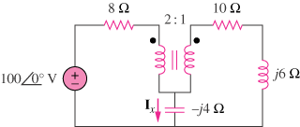

Figure 13.112

Solution

We apply mesh analysis.
8 2:1 10

+ +

+ V₁ V₂
I₁ - j6
100∠0º V - I₂
-
I_{x}
-j4

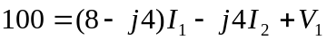 (1)

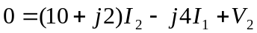 (2)
But
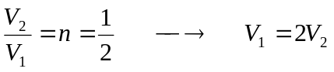 (3)

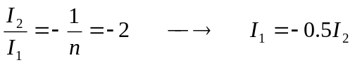 (4)

Substituting (3) and (4) into (1) and (2), we obtain

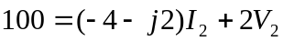 (1)a
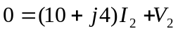 (2)a

Solving (1)a and (2)a leads to I₂ = -3.5503 +j1.4793

